1. Aim
The aim of this experiment is to perform task analysis for an online shopping application, document the user flow, and create corresponding wireframes using Lucidchart.

2. Objective
- To understand how users interact with an online shopping application.
- To break down user actions into smaller tasks using task analysis.
- To create user flow diagrams that represent the sequence of user interactions.
- To design wireframes that represent the basic structure of the application interface.

3. Tools Used
- Lucidchart – for creating flowcharts and wireframes
- Web Browser – for accessing Lucidchart
- Microsoft Word – for documentation

4. Introduction
Task analysis is a process used in User Interface Design (UID) to understand how users perform tasks in a system. It breaks a task into smaller steps to identify the user’s goals, actions, and decision points. This helps designers create more intuitive and user-friendly applications.
In this experiment, an online shopping application is analyzed to understand how users browse products, add items to the cart, and complete the purchase process. The user interactions are represented using flowcharts and wireframes created in Lucidchart.

5. Task Analysis
Task analysis identifies the sequence of actions a user performs to complete a task.
Main Task
Purchase a product using an online shopping application.
Sub Tasks
- Open the application.
- Login or register an account.
- Browse or select product categories.
- Search for a specific product.
- View product details.
- Add the product to the shopping cart.
- Proceed to checkout.
- Select payment method.
- Enter shipping details.
- Confirm the order.

6. User Flow Description
The user flow represents the step-by-step journey of a user in the application.
Flow Steps
- Start
- User opens the application.
- System checks if the user has an account.
- If the user does not have an account → Register.
- If the user already has an account → Login.
- After login, the user selects a product category.
- User searches for a product.
- The application displays product details.
- User adds the product to the cart.
- User proceeds to payment.
- Payment method is selected:
- Online payment
- Cash on delivery
- User enters shipping details.
- System displays order confirmation.
- End of process.

7. Wireframe Description
Wireframes represent the basic layout and structure of the application screens without detailed design elements.
Wireframes Created
The following screens were designed:
- Login Screen
  - Username field
  - Password field
  - Login button
  - Register option
- Product Category Screen
  - List of product categories
  - Search bar
- Product Details Screen
  - Product image
  - Product name
  - Price
  - Add to cart button
- Cart Screen
  - Selected product list
  - Quantity
  - Checkout button
- Payment Screen
  - Payment method selection
  - Online payment option
  - Cash on delivery option
- Order Confirmation Screen
  - Order details
  - Delivery information
  - Confirmation message

8. Procedure
- Open a web browser and go to Lucidchart.
- Create a new document.
- Use flowchart shapes to design the user flow.
- Add process boxes for actions such as login, search, and add to cart.
- Add decision diamonds for steps like payment method selection.
- Connect the steps using arrows to represent the flow.
- Create wireframes using rectangles and placeholders for UI elements.
- Save and export the diagram if needed.

9. Result
The task analysis for an online shopping application was successfully completed. The user flow and wireframes were created using Lucidchart, which clearly represent the interaction steps involved in purchasing a product.
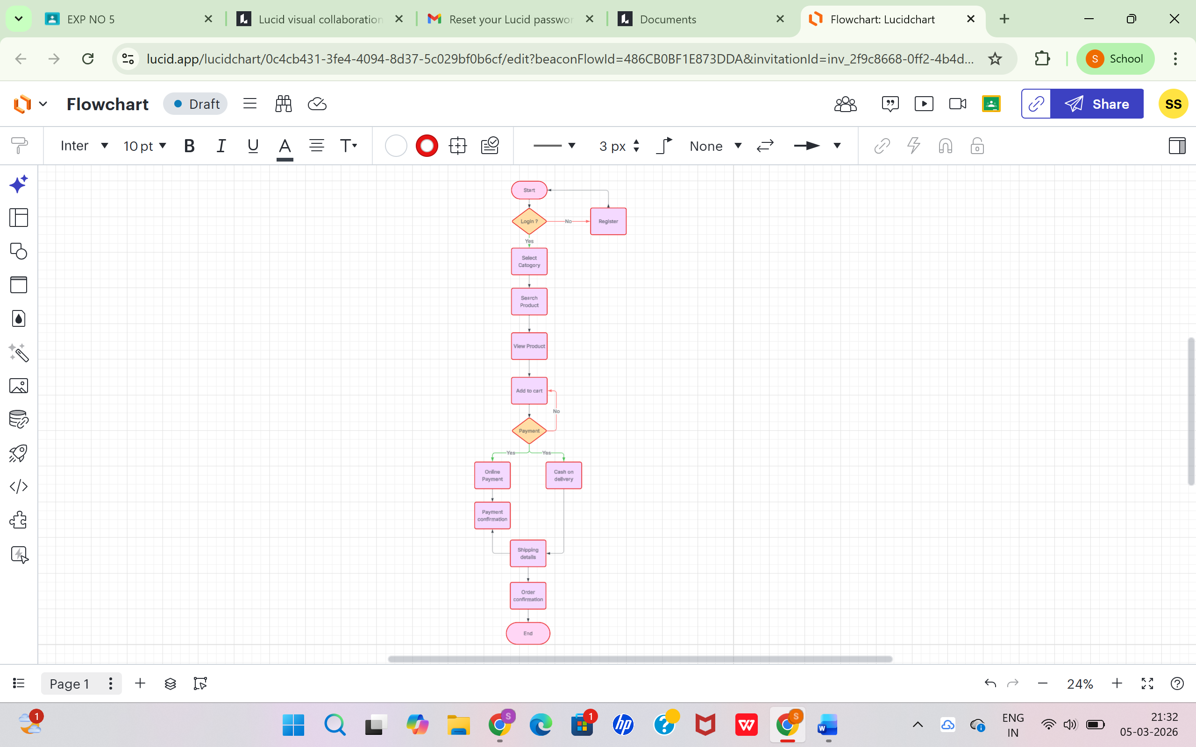

10. Conclusion
This experiment helped in understanding how task analysis improves user interface design by identifying user actions and decision points. Creating user flows and wireframes provides a clear representation of how users interact with an application, which helps designers build more efficient and user-friendly systems.

